COMMUNITY ENGAGEMENT PROJECT (CEP) (22pt. Times New Roman)
PROJECT TITLE (20pt Times New Roman)
Submitted in Partial Fulfilment
of the Requirements for the Award of the Degree
of
BACHELOR OF SCIENCE (INFORMATION TECHNOLOGY / DATA SCIENCE)
SEMESTER V
By
Student Name
Roll Number:
Under the esteemed guidance of
Guide Name

Assistant/Associate Professor,

Department of Computing


DEPARTMENT OF COMPUTING
VIDYALANKAR SCHOOL OF INFORMATION TECHNOLOGY
(Autonomous College affiliated to University of Mumbai)
MUMBAI, 400037
MAHARASHTRA
2026 - 2027

VIDYALANKAR SCHOOL OF INFORMATION TECHNOLOGY
(Autonomous College affiliated to University of Mumbai)
MUMBAI-MAHARASHTRA-400037

DEPARTMENT OF COMPUTING

CERTIFICATE
I hereby certify that Mr./Ms. _____________________ (Roll Number: 24302_____), Student of Vidyalankar School of Information Technology, studying in T.Y. B.Sc. (Information Technology / Data Science ) Semester V has completed a C.E. project titled “NAME OF THE PROJECT” at “NAME OF THE ORGANISATION” during the academic year 2026-27.

Internal Guide |  | Head of Department  Department of Computing
Internal Examiner |  | External Examiner
Date: |   College Seal |  | Principal

ATTACH Organization Visit Observation Sheet DULY SIGNED BY YOUR INDUSTRY REPORTING OFFICER AND MENTOR
ATTACH Project Guide Meeting Record DULY SIGNED BY YOUR MENTOR

DECLARATION
I, Mr. / Mrs. Name of the Student Student of Vidyalankar School of Information Technology, studying in T.Y. B.Sc. in Information Technology / Data Science, hereby declare that I have completed the C.E. project entitled “Name of the C.E. Project” during the academic year 2026-27
The information presented in this report has been collected through interactions, observations, interviews, surveys, organizational records, and project activities undertaken during the field visits.
Due credit is extended on the work of Literature/Secondary Survey by endorsing it in the Bibliography as per prescribed format.

Signature of the Student with Date
Name of Student

ACKNOWLEDGEMENT
We express our sincere gratitude to the University of Mumbai and Vidyalankar School of Information Technology for providing us an opportunity to undertake this Community Engagement Project.
We extend our heartfelt thanks to our Faculty Mentor, Guide Name, for his/her constant guidance, encouragement, and constructive feedback, which greatly helped us in completing this project successfully.
We are equally grateful to Organisation Name for granting us the opportunity to visit and work on the project. The support and cooperation received from the staff members gave us meaningful exposure and helped us connect our academic knowledge with the available Sustainable Development Goal (SDG Number).
Lastly, we wish to thank our peers and faculty members for their support and motivation, which made this project a collaborative and enriching experience.
ABSTRACT
The abstract should contain:
- Name of the organization
- Problem identified
- Objective of the project
- Method of requirement gathering
- Proposed solution
- Technologies used
- Key outcomes achieved
- Impact on organization/community
(250–300 words)
TABLE OF CONTENT
CHAPTER 1: INTRODUCTION 11
1.1 Project Background 11
1.2 Problem Statement 11
1.3 Need for the Project 11
1.4 Objectives 11
1.5 Scope 11
1.6 SDG Alignment 12
CHAPTER 2: REQUIREMENT ANALYSIS AND LITERATURE REVIEW 13
2.1 Methodology Adopted 13
2.2 Stakeholder Interactions 13
2.3 Domain Overview 13
2.4 Existing Process Analysis 13
2.5 Existing Solutions and Related Work 13
2.6 Technologies Studied 13
2.7 Research Gap and Need for Proposed Solution 14
2.8 Challenges Identified 14
CHAPTER 3: PROPOSED SOLUTION 15
3.1 Solution Overview 15
3.2 System Architecture 15
3.3 Process Flow Diagram 15
3.4 Module Description 15
3.5 Advantages of Proposed Solution 15
CHAPTER 4: SYSTEM DESIGN 16
4.1 System Design Overview 16
4.2 Use Case Diagram 16
4.3 Workflow Diagram 16
4.4 Module Design 16
CHAPTER 5: PROJECT IMPLEMENTATION 17
5.1 Development Methodology 17
5.2 Module-wise Implementation 17
5.3 User Interface Solution 17
5.4 Screenshots of Developed Solution 17
CHAPTER 6: TESTING AND VALIDATION 18
6.1 Test Cases 18
6.2 Test Results 18
6.3 User Acceptance Testing 18
6.4 Feedback from Stakeholders 18
6.5 Performance Evaluation 18
CHAPTER 7: RESULTS AND IMPACT ASSESSMENT 19
7.1. Deliverables Submitted 19
7.2. Results Achieved 19
7.3. Impact on Organization 19
7.4. SDG Contribution 19
CHAPTER 8: CONCLUSION AND FUTURE SCOPE 20
8.1. Conclusion 20
8.2. Key Findings 20
8.3. Recommendations 20
8.4. Future Enhancements 20
REFERENCES 21
Research Papers 21
Books Referred 21
Website 21
Annexures (Highly Recommended) 22

TABLE OF FIGURES
Figure 1: Key Component of Database 13

CHAPTER 1: INTRODUCTION

Project Background
This section introduces the project and provides the context in which it was undertaken. It should describe the organization or community, the area of work related to the project, and the circumstances that led to the identification of the problem. The section helps readers understand the significance and relevance of the project.

Problem Statement
This section explains why the project is necessary and how the proposed solution can help address the identified problem. It should justify the development of the project from both organizational and community perspectives. History and mission of the NGO

Need for the Project
This section explains why the project is necessary and how the proposed solution can help address the identified problem. It should justify the development of the project from both organizational and community perspectives.

Objectives
This section lists the goals that the project aims to achieve. Objectives should be specific, measurable, and aligned with the identified problem.
Primary Objectives
The main goals that directly address the problem.
Secondary Objectives
Additional goals that enhance the effectiveness, usability, or long-term value of the solution.

Scope
This section defines the boundaries of the project by specifying what is included and what is excluded. It should clearly outline the features, functions, and deliverables that will be completed wi21thin the project duration.

SDG Alignment
This section explains how the project contributes to one or more United Nations Sustainable Development Goals (SDGs). Students should identify the relevant SDG(s) and describe the connection between the project objectives and the selected goal(s).

CHAPTER 2: REQUIREMENT ANALYSIS AND LITERATURE REVIEW
This chapter presents the process of understanding the problem through stakeholder interactions, observations, and requirement gathering activities. It also reviews existing solutions, technologies, and research studies related to the project domain. The chapter establishes the need for the proposed solution by identifying gaps in the current system and existing approaches.

Methodology Adopted
This section describes the approach used to gather information and understand the problem. Students should mention the methods used during field visits and stakeholder interactions.

Stakeholder Interactions
This section presents details of the individuals or groups consulted during the project. It should explain how their inputs contributed to understanding the problem.

Domain Overview
This section introduces the project domain and provides theoretical background relevant to the problem area.

Existing Process Analysis
This section explains the current workflow or system being followed before the proposed solution. Students should identify inefficiencies, challenges, and limitations.

Existing Solutions and Related Work
This section reviews existing software, systems, applications, research papers, case studies, and methodologies related to the project.

Technologies Studied
This section discusses the technologies evaluated before selecting the final technology stack.

Research Gap and Need for Proposed Solution
This section identifies the limitations of existing solutions and explains why a new or improved solution is required.

Challenges Identified
This section summarizes the problems and difficulties identified through stakeholder interactions and observations.

CHAPTER 3: PROPOSED SOLUTION

This chapter presents the solution proposed to address the problem identified during the requirement gathering phase. It explains the overall approach, architecture, technologies selected, and the expected advantages of the proposed system.

Solution Overview
This section provides a high-level description of the proposed solution and explains how it addresses the identified problem.

System Architecture
This section describes the overall architecture of the proposed system and the interaction between various components.

Process Flow Diagram
This section illustrates the workflow of the proposed system through diagrams or flowcharts.

Module Description
This section explains each module of the proposed system and its intended functionality.

Advantages of Proposed Solution
This section highlights the expected benefits of the proposed system.

CHAPTER 4: SYSTEM DESIGN

This chapter explains the detailed design of the proposed system using diagrams, models, and design specifications before implementation begins.

System Design Overview
This section provides an overview of the design approach adopted for the project.

Use Case Diagram
This section identifies the actors and functionalities of the system.

Workflow Diagram
This section describes the sequence of activities performed in the system.

Module Design
This section elaborates on the internal design of individual modules.

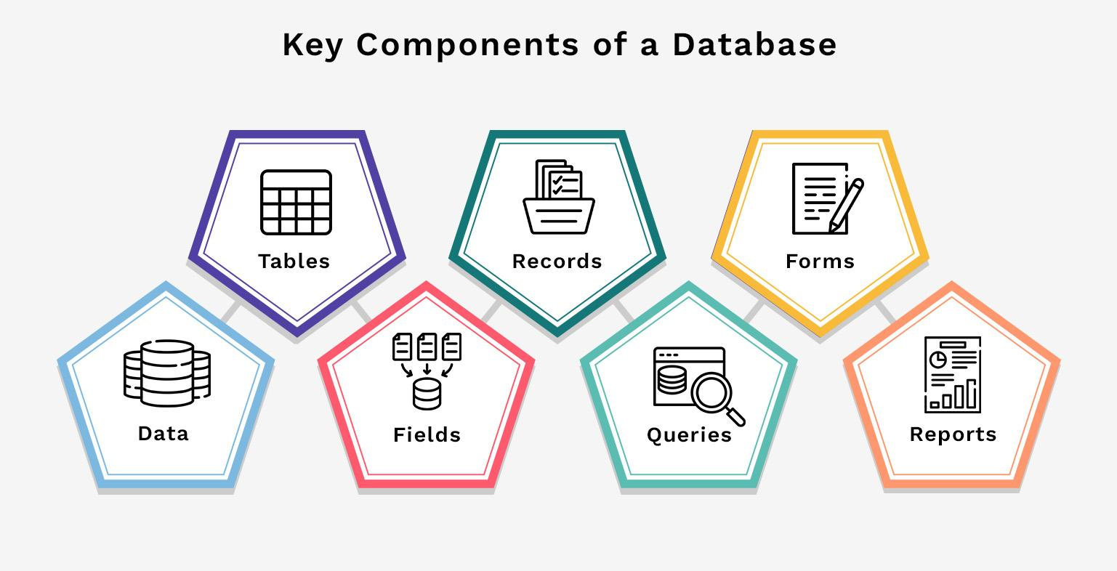
Figure 1: Key Component of Database

CHAPTER 5: PROJECT IMPLEMENTATION

This chapter describes the actual development and implementation of the project.

Development Methodology
This section explains the development approach followed during implementation.

Module-wise Implementation
This section explains how each module was developed.

User Interface Solution
This section discusses the development of user interfaces.

Screenshots of Developed Solution
This section provides evidence of project implementation.

CHAPTER 6: TESTING AND VALIDATION
This chapter verifies whether the developed solution meets its intended objectives and functions correctly.

Test Cases
This section presents the test scenarios used to validate system functionalities.

Test Results
This section summarizes testing outcomes.

User Acceptance Testing
This section documents validation by stakeholders or users.

Feedback from Stakeholders
This section summarizes suggestions received during validation.

Performance Evaluation
This section evaluates the effectiveness of the solution.

CHAPTER 7: RESULTS AND IMPACT ASSESSMENT
This chapter presents the outcomes achieved after implementation and evaluates the impact on stakeholders and the organization.

Deliverables Submitted
This section lists all project outputs provided to the organization. (Like App/ System, Database, Reports, Documentation, LAB MANUAL)

Results Achieved
This section discusses the achievements obtained through the project.

Impact on Organization
This section describes organizational benefits resulting from the project.

SDG Contribution
This section demonstrates alignment with Sustainable Development Goals.

CHAPTER 8: CONCLUSION AND FUTURE SCOPE
This chapter summarizes the project, highlights major findings, and recommends future improvements.

Conclusion
This section provides an overall summary of the project and its achievements.

Key Findings
This section presents significant observations and outcomes.

Recommendations
This section suggests improvements for the organization and future users.

Future Enhancements
This section discusses additional features that can be developed in future versions.

REFERENCES

Research Papers
- Reference Paper 1
- Reference Paper 2
- Reference Paper 3
Citing needs to be taken from Google Scholar by following the steps:
- Go to Google Scholar (Link: https://scholar.google.com/)
- Type the title of your paper in Search Bar.
- Find the paper you have referred from the list of papers published by the authors on same or similar topic.
- Click on Cite option present at the bottom of each paper.
- A new popup will open, indicating various citing formats. You need to select MLA format

Books Referred
- Books referred 1
- Books Referred 2
Citing of Books needs to be done in the format mentioned for citing Reference Papers.

Website
- Website Link 1: Topic(s) referred
- Website Link 2: Topic(s) referred

Annexures (Highly Recommended)
Each Annexure should start from fresh page
Annexure A*
Field Visit Photographs (Day wise phots needs to be attached)
Annexure B*
Survey Questionnaire / Interview Questions (Prepared in consultation with your Mentor. If you have both then they needs to be attached under separate ANNEXURES)
Annexure C*
Interview Questions. (If Applicable)
Annexure D*
Reporting Officer Feedback Form(s) on the prepared project (Blank Format)
Annexure G*
Source Code Repository Link and also provide the list of the contents uploaded (GitHub)
Annexure H
User Manual

* Mandatory Annexures

IMPORTANT INSTRUCTIONS

Paper Size: A4
Font: Times New Roman
Text Size: 11 pt
Heading 1: 18 pt Bold UPPERCASE
Heading 2: 18 pt Bold
Heading 3: 16 pt Bold
Line Spacing: 1.5
Alignment: Justified
Margins: Left 2.54cm, Others 2.54cm
Page Number: Bottom Center
Figure Caption: Below Figure
Table Caption: Above Table
References: MLA Format
TOC: Automatic
List of Figures/Tables: Automatic

